1. Limit overrun race conditions 1

2. Bypassing rate limits via race conditions 5

3. Multi-endpoint race conditions 8

4. Single-endpoint race conditions 13

5. Exploiting time-sensitive vulnerabilities 18

# Limit overrun race conditions

# Bypassing rate limits via race conditions

# Multi-endpoint race conditions

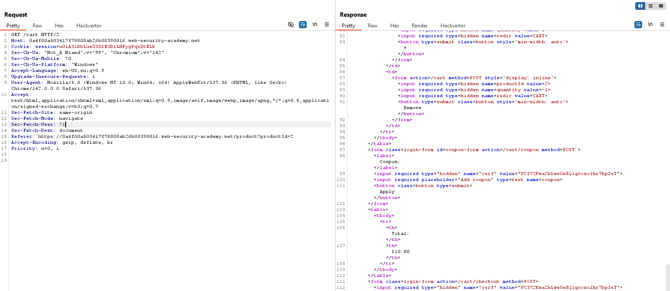

Look at the time

Now take a get request to homepage to the start of the group. Lets see the time of the second request (the first one in the begin).

Change the productID to 1 (lethal jacket)

Can see that error insufficient_funds above

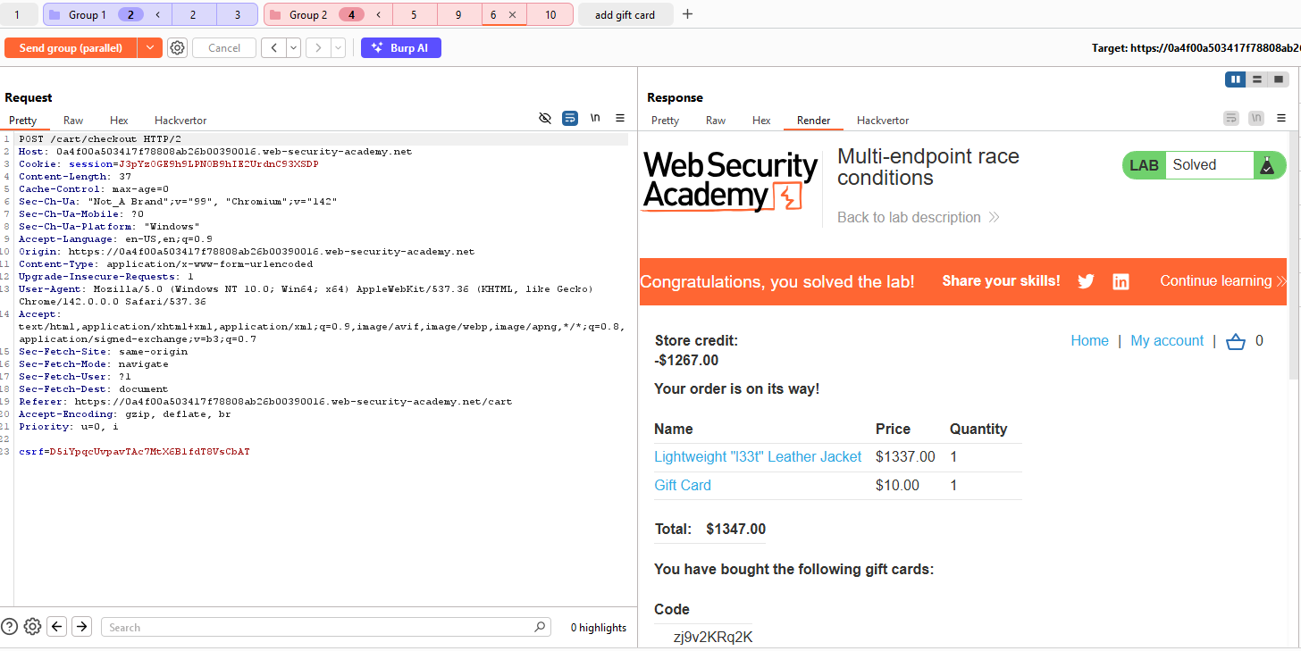

# Single-endpoint race conditions

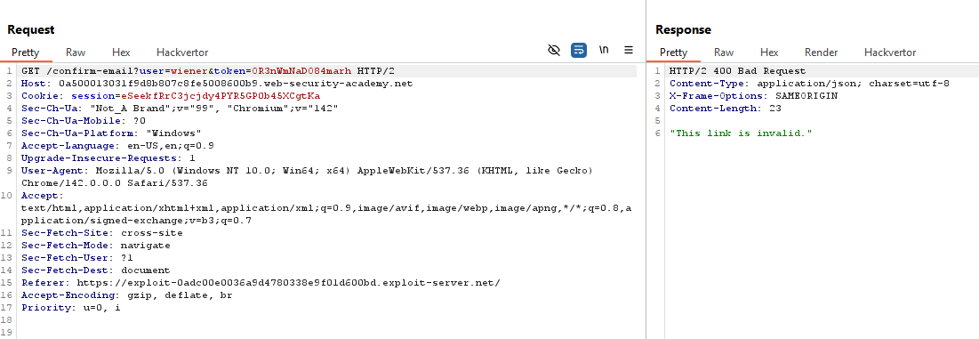

Duplicate 19

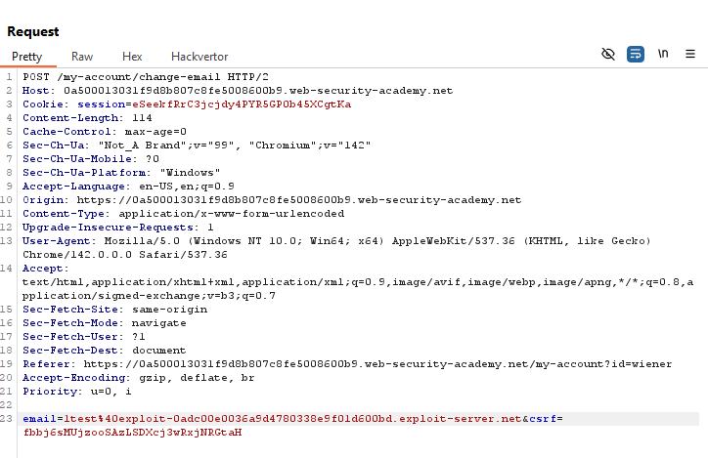

Send the group of requests in sequence over separate connections

end the group of requests again, but this time in parallel

In Repeater, create a new group containing two copies of the POST /my-account/change-email request.

Change the email parameter of the other request to carlos@ginandjuice.shop.

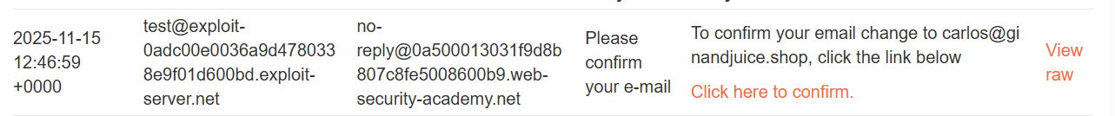

# Exploiting time-sensitive vulnerabilities

Có thể cho rằng web sử dụng PHP backend dựa vào header cookie







